The following information applies to both high and low profile models.

This ROHO cushion and pump requires a therapist to adjust the cushion for maximum benefit.

THE Concept behind the ROHO cushion
The object of the adjustment procedure is to “immerse” the user as deeply as possible in the cushion without bottoming out. Deep immersion is achieved by having as little internal air pressure in the cushion as possible without allowing any part of the body, especially the bony prominences, to touch the base of the cushion.

Proper adjustment or verification of the air pressure can only be done while the user is siting in the cushion. Place your fingertips between the person and the cushion as a gauge for determining the appropriate immersion depth.

Note: Your DRY FLOTATION product is most effective when properly adjusted. Protect it from pins and other sharp objects and exposure to hot cigarette ashes.

Cleaning Instructions
- Ensure that the valve(s) are closed
- Rinse in cold water
- Immerse and wash carefully and thoroughly by hand in hot water with a neutral low foaming, general-purpose detergent of choice (washing-up liquid is usually sufficient). It can be scrubbed with a soft brush to remove any stubborn deposits
- Rinse and hand dry (a low temperature hair dryer may be employed, but beware that, if the air inside the cushion or mattress increases in temperature, it may require readjustment before use).

WARNING:
Do not use oil-based lotions, or phenolic-based disinfectants on your cushion as they may compromise the integrity of the rubber.

Steps to properly adjust the ROHO cushion
- Turn cushion valve counter-clockwise to open

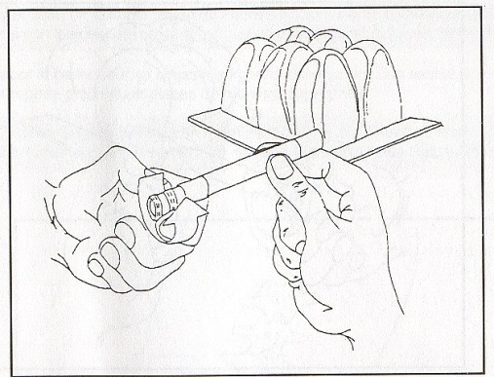

- Place hand pump hose over valve and inflate until cushion arches slightly

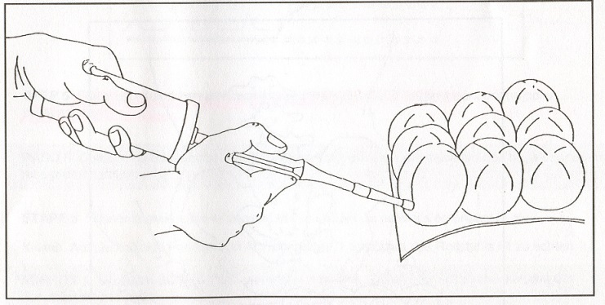

- Remove pump hose from valve and turn valve clockwise to close

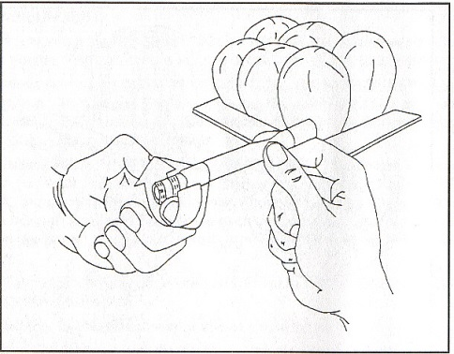

- With cushion in this over-inflated condition, place the individual on the cushion in his/her normal siting position with arm and foot rests properly placed

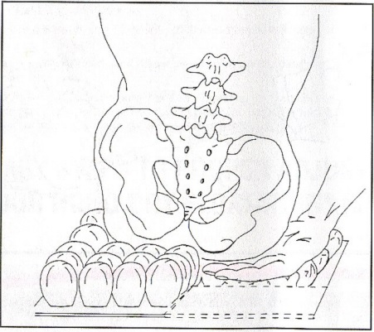

- Place your hand between cushion and the individuals deepest penetrating bony prominence

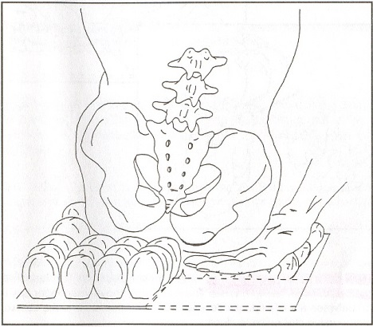

- With your hand in place, slowly turn valve counter-clockwise to release some air to immerse the individual in the cushion. When you can barely move your fingertips (approx. 1.25cm) between the individual’s deepest bony prominence and the cushion base, pinch valve stem and turn valve clockwise to close.
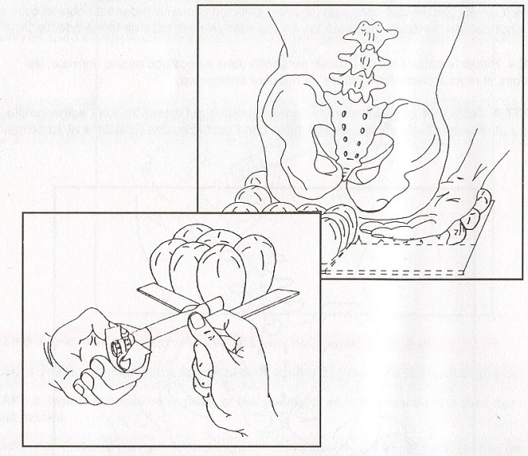

CAUTION
DO NOT BOTTOM OUT. If any part of the individual is touching the cushion base, too much air has been released and the therapeutic value of the cushion will be lost. To fix, repeat the entire procedure.

Be sure to check the cushion daily to ensure that you have not “bottomed out” and that the cushion is adjusted correctly.

Special Instructions
Only after adjustment is made for the lowest bony prominence, should other compartments be adjusted for comfort or for positioning needs.

Covers and cleaning
A ROHO cover is included with every standard cushion to help with protection of the cushion surface, keeping the cushion cells from protruding beyond the wheelchair seat, and aiding in slide transfers. And because the bottom of the cover is made from a special non-skid material, the cushion does not move in the chair.

To cover your cushion, follow these simple instructions:
- Unfold the cover, with the black material facing upward and the zipper facing down
- Insert your ROHO DRY FLOTATION cushion into the cover with the air cells down
- Gently pull a grommet corner of your cushion through an opening at the corner of the cover until the metal grommet is exposed. Repeat this procedure until all four grommets are showing (be careful when pulling the valve stem and rope through the opening)
- Carefully close the zipper, turn the cushion over and your ROHO DRY FLOTATION cushion is now ready for use.

If properly fitted, the cushion will sit flat on the chair (black non skid material on the bottom) with all cells covered and all four grommets showing.

- WARNING
Never use the ISOFLO Control Valve as a handle. Pulling on the valve mechanism may cause it to leak air. Always follow these simple procedures.
- When necessary, use the handle strap on your cushion cover as a handle
- Check your cushion for proper inflation at least daily.

Always consult appropriate therapist regarding safety and usage of this equipment.

If you experience problems with equipment on loan from MND Victoria, please contact us immediately on (03) 9830 2122

